REVIEW 3

1. **Database Relationship Diagram**

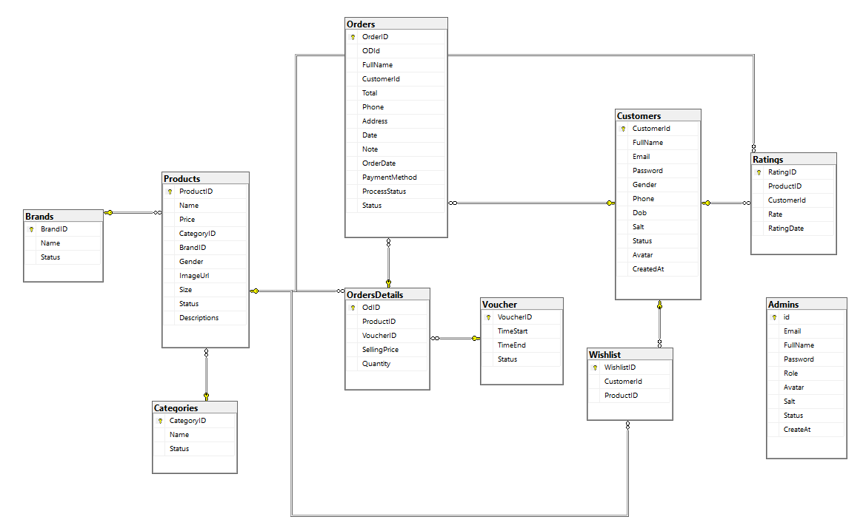

1. **Table Definition**
2. **Customer**

|  |  |  |  |  |  |  |
| --- | --- | --- | --- | --- | --- | --- |
| **Field Name** | **DataType** | **Null** | **Default Value** | **Key** | **Table-Field-Ref** | **Description** |
| CustomerId | int | No | Identity | PK |  | Customer ID |
| FullName | nvarchar | No |  |  |  | Full Name |
| Email | varchar | No |  |  |  | Email Customer |
| Password | varchar | No |  |  |  | Password Customer |
| Gender | bit | Yes |  |  |  | Gender |
| Phone | Varchar | Yes |  |  |  | Phone Customer |
| Dob | Date | Yes |  |  |  | Date of birth |
| Salt | Varchar | No |  |  |  | Password encryption code |
| Status | bit | Yes | Yes |  |  | Status customer |
| Avatar | nvarchar | Yes | Avatar Guest |  |  | Avatar Customer |
| CreateAt | date | Yes | getDate |  |  | Created Date |

1. **Categories**

|  |  |  |  |  |  |  |
| --- | --- | --- | --- | --- | --- | --- |
| **Field Name** | **DataType** | **Null** | **Default Value** | **Key** | **Table-Field-Ref** | **Description** |
| CategoryId | int | No | Identity | PK |  | Category ID |
| Name | nvarchar | No |  |  |  | Name Category |
| Status | Bit | Yes |  |  |  | Status |

1. **Brands**

|  |  |  |  |  |  |  |
| --- | --- | --- | --- | --- | --- | --- |
| **Field Name** | **DataType** | **Null** | **Default Value** | **Key** | **Table-Field-Ref** | **Description** |
| BrandId | int | No | Identity | PK |  | Brand ID |
| Name | nvarchar | No |  |  |  | Name Category |
| Status | Bit | Yes |  |  |  | Status |

1. **Products**

|  |  |  |  |  |  |  |
| --- | --- | --- | --- | --- | --- | --- |
| **Field Name** | **DataType** | **Null** | **Default Value** | **Key** | **Table-Field-Ref** | **Description** |
| ProductId | int | No | Identity | PK |  | ProductID |
| Name | nvarchar | No |  |  |  | Product Name |
| Price | float | No |  |  |  | Price |
| CategoryID | int | No |  | FK | CategoryID (Categories) | Product Category |
| BrandID | int | No |  | FK | BrandID (Brands) | Product Brand |
| Gender | varchar | Yes |  |  |  | Gender |
| ImageUrl | nvarchar | No |  |  |  | Product Image |
| Size | varchar | Yes |  |  |  | Product Size |
| Status | bit | Yes |  |  |  | Product Status |
| Description | nvarchar | Yes |  |  |  | Product Description |

1. **Ratings**

|  |  |  |  |  |  |  |
| --- | --- | --- | --- | --- | --- | --- |
| **Field Name** | **DataType** | **Null** | **Default Value** | **Key** | **Table-Field-Ref** | **Description** |
| RatingID | Int | No | Identity | PK |  | Rate ID |
| ProductID | Int | No |  | FK | ProductID (Products) | Rated Product |
| CustomerID | Int | No |  | FK | CustomerID (Customers) | Customer ID |
| Rate | Int | No |  |  |  | Rating Values |
| RatingDate | Date | Yes | getDate |  |  | Rating Date |

1. **Orders**

|  |  |  |  |  |  |  |
| --- | --- | --- | --- | --- | --- | --- |
| **Field Name** | **DataType** | **Null** | **Default Value** | **Key** | **Table-Field-Ref** | **Description** |
| OrderID | int | No | identity | PK |  | Order ID |
| ODId | Int | No |  | FK | OdId (OrdersDetails) | OrdersDetails Id |
| FullName | Nvarchar | No |  |  |  | Receiver Name |
| CustomerId | int | Yes |  | FK | CustomerID (Customers) | Customer ID if login |
| Total | float | No |  |  |  | Total payment |
| Phone | varchar | Yes |  |  |  | Receiver Phone |
| Address | nvarchar | No |  |  |  | Receiver Address |
| Date | date | Yes |  |  |  | Ship Date |
| Note | nnvarchar | Yes |  |  |  | Receiver Note |
| OrderDate | date | Yes | getDate |  |  | Get Order Date |
| Payment Method | nvarchar | No |  |  |  | Payment method |
| ProcessStatus | nvarchar | No |  |  |  | Order Process |
| Status | bit | Yes |  |  |  | Order status |

1. **OrdersDetails**

|  |  |  |  |  |  |  |
| --- | --- | --- | --- | --- | --- | --- |
| **Field Name** | **DataType** | **Null** | **Default Value** | **Key** | **Table-Field-Ref** | **Description** |
| OdId | Int | No | identity | PK |  | OrdersDetails ID |
| ProductID | Int | No |  | FK | ProductId (Products) | Product Id |
| VoucherID | Int | Yes |  | FK | VoucherID (Voucher) | Voucnher Id |
| SellingPrice | Float | No |  |  |  | Price |
| Quantity | int | No |  |  |  | Quantity |

1. **Wishlist**

|  |  |  |  |  |  |  |
| --- | --- | --- | --- | --- | --- | --- |
| **Field Name** | **DataType** | **Null** | **Default Value** | **Key** | **Table-Field-Ref** | **Description** |
| WishlishID | Int | No | identity | PK |  | Wishlish ID |
| CustomerID | Int | No |  | FK | CustomerID(Customers) | Customer ID |
| ProductID | int | no |  | FK | ProductID (Products) | Product ID |

1. **Voucher**

|  |  |  |  |  |  |  |
| --- | --- | --- | --- | --- | --- | --- |
| **Field Name** | **DataType** | **Null** | **Default Value** | **Key** | **Table-Field-Ref** | **Description** |
| VoucherID | Int | No | identity | PK |  | Voucher ID |
| TimeStart | Date | Yes |  |  |  | Time Start voucher |
| TimeEnd | Date | Yes |  |  |  | Time end voucher |
| Status | bit | Yes |  |  |  | Status voucher |

1. **Contact**

|  |  |  |  |  |  |  |
| --- | --- | --- | --- | --- | --- | --- |
| **Field Name** | **DataType** | **Null** | **Default Value** | **Key** | **Table-Field-Ref** | **Description** |
| ContactID | Int | No | identity | PK |  | Contact ID |
| FullName | nvarchar | No |  |  |  | Name |
| Phone | Varchar | No |  |  |  | Phone |
| Email | Varchar | Yes |  |  |  | Email |
| Description | nvarchar | no |  |  |  | Description |

1. **Admins**

|  |  |  |  |  |  |  |
| --- | --- | --- | --- | --- | --- | --- |
| **Field Name** | **DataType** | **Null** | **Default Value** | **Key** | **Table-Field-Ref** | **Description** |
| Id | Int | No | Identity | PK |  | Admin ID |
| Email | Varchar | Yes |  |  |  | Admin Email |
| Fullname | nvarchar | Yes |  |  |  | Admin Name |
| Password | varchar | Yes |  |  |  | Admin Password |
| Role | Nvarchar | Yes |  |  |  | Admin Role |
| Avatar | Varchar | Yes |  |  |  | Admin Avatar |
| Salt | Varchar | Yes |  |  |  | Password Encryption Code |
| Status | Bit | Yes |  |  |  | Status |
| CreateAt | date | Yes | getDate |  |  | Get Date Create |

1. **Site Maps**
2. **Customer site**

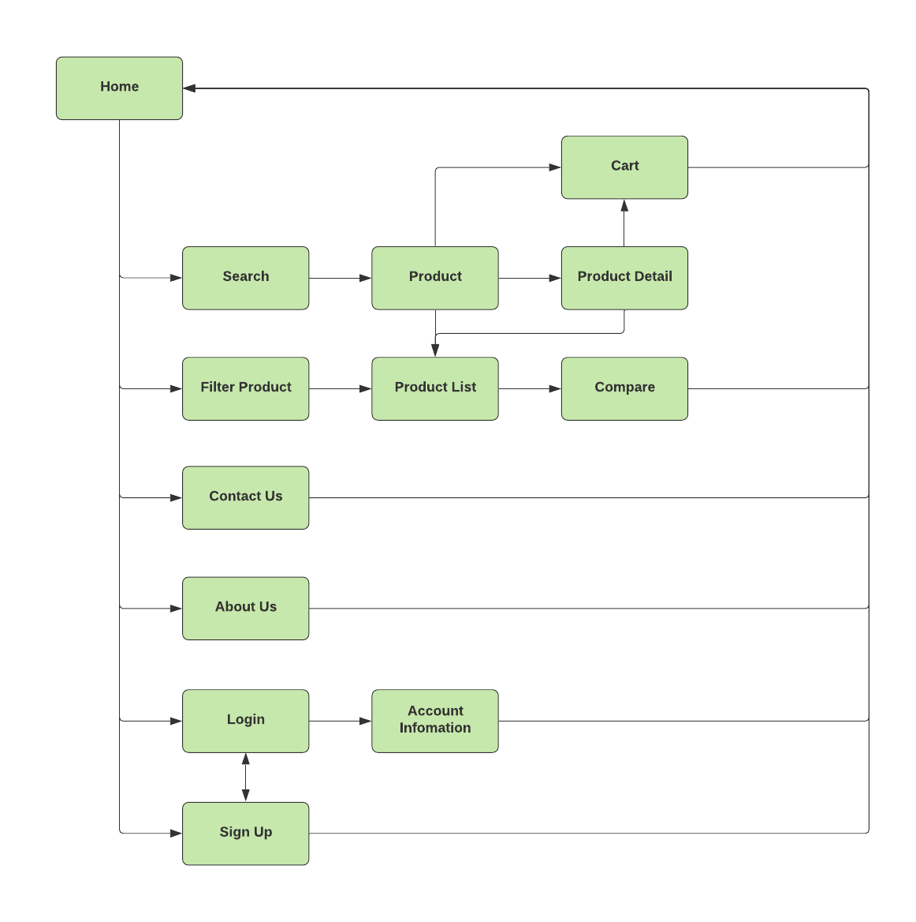

1. 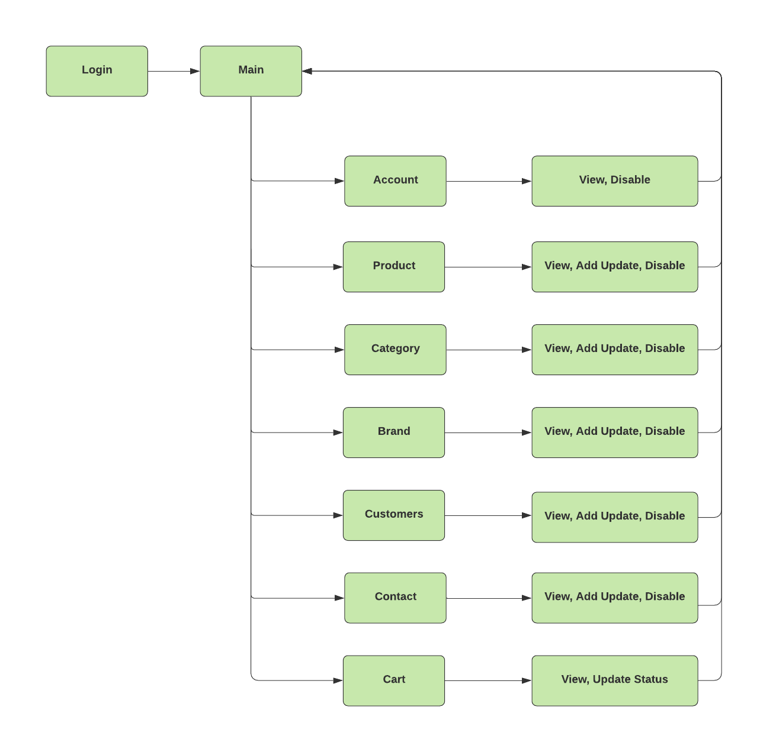**Admin Site**
2. **Customers GUI Designc**
3. **Template:**

This is the template of all user page.

1. Header:
2. 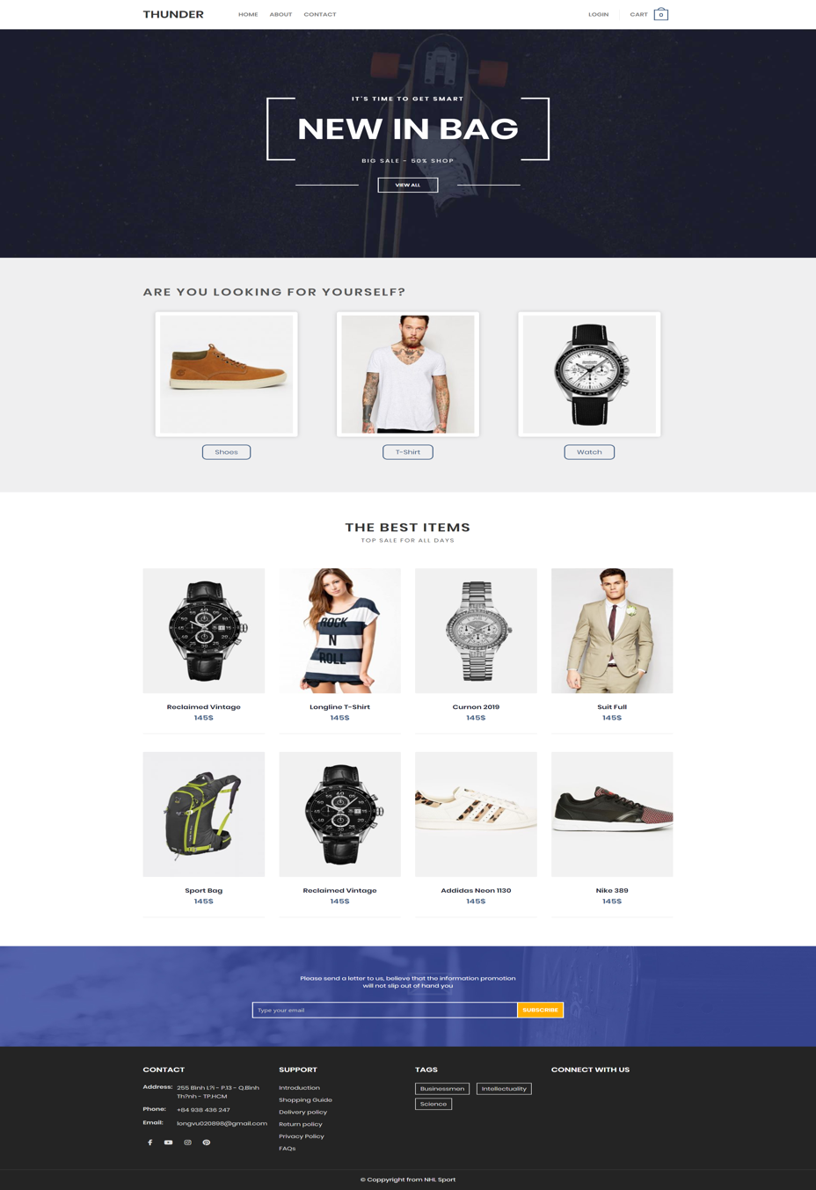**Home:**
3. **Login customer:**

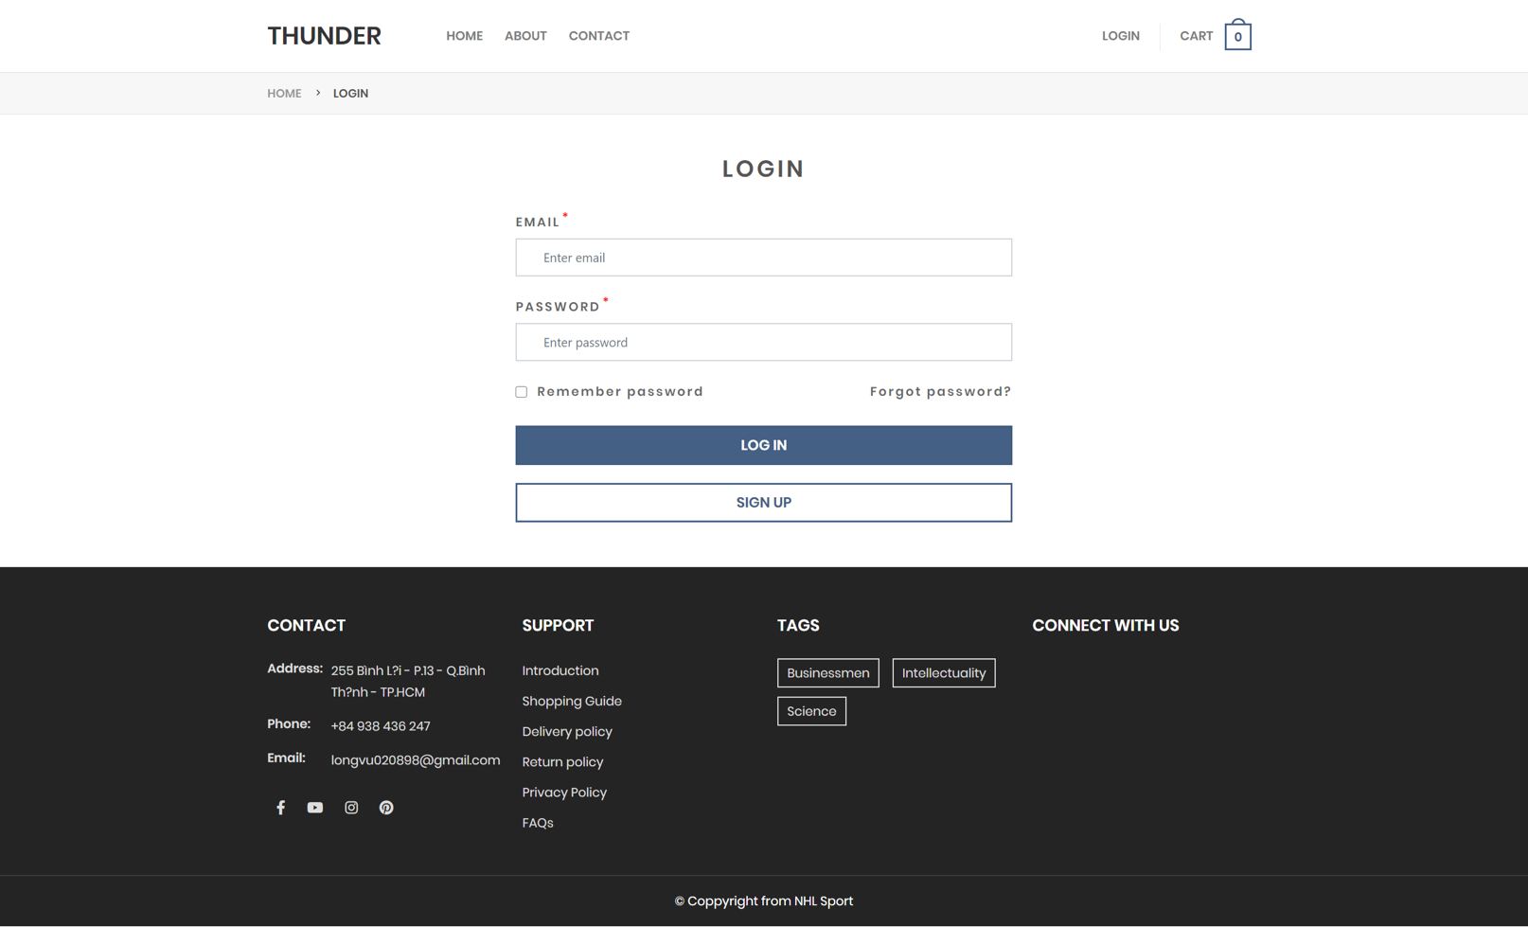

1. **Sign up customer:**

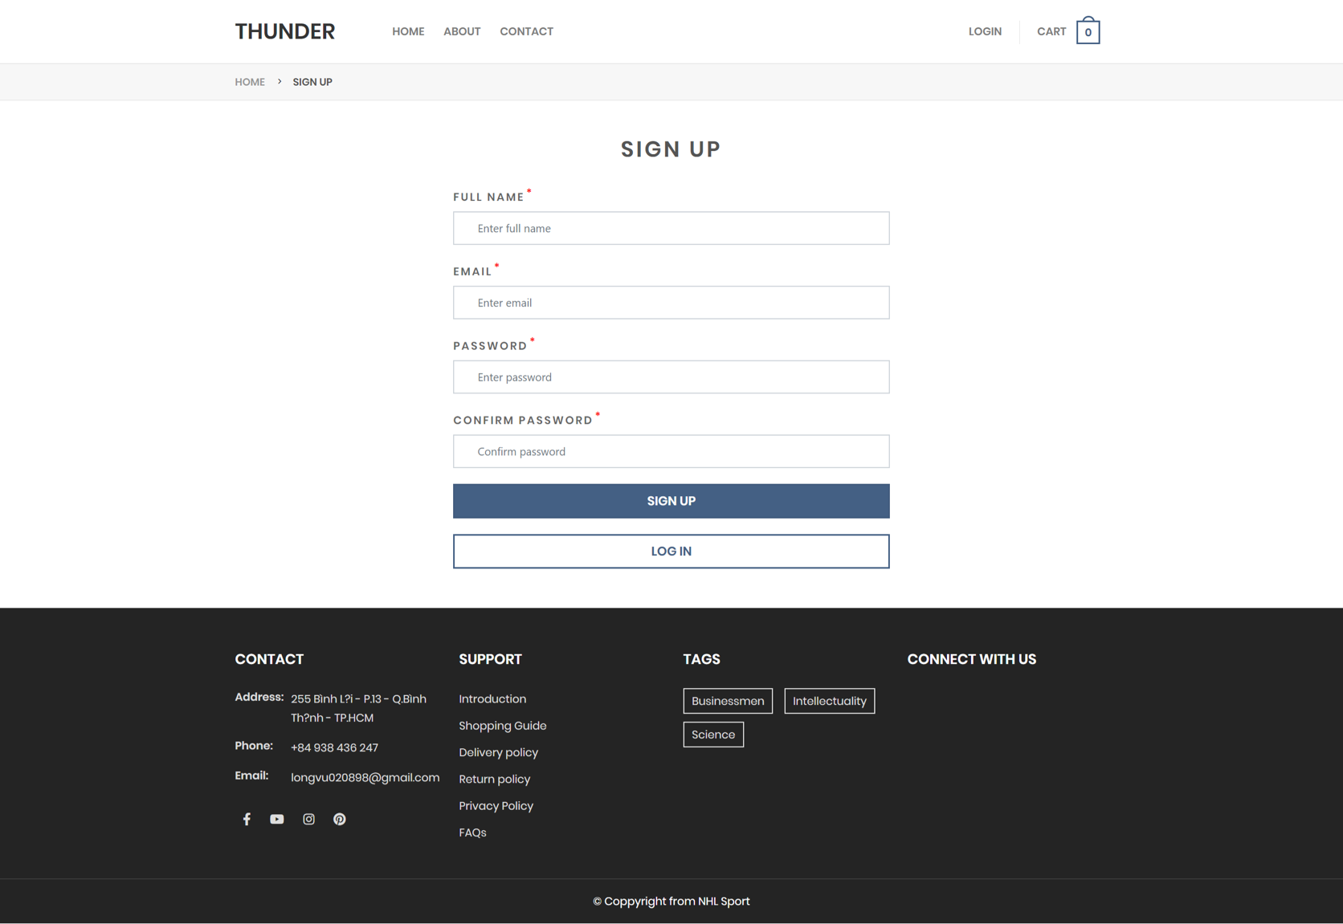

1. 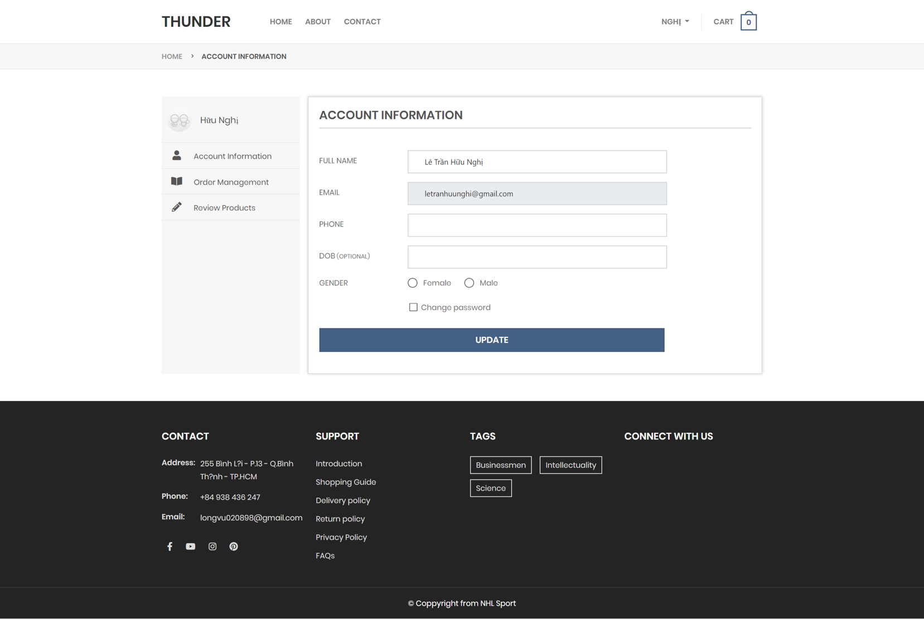**Profile customer:**

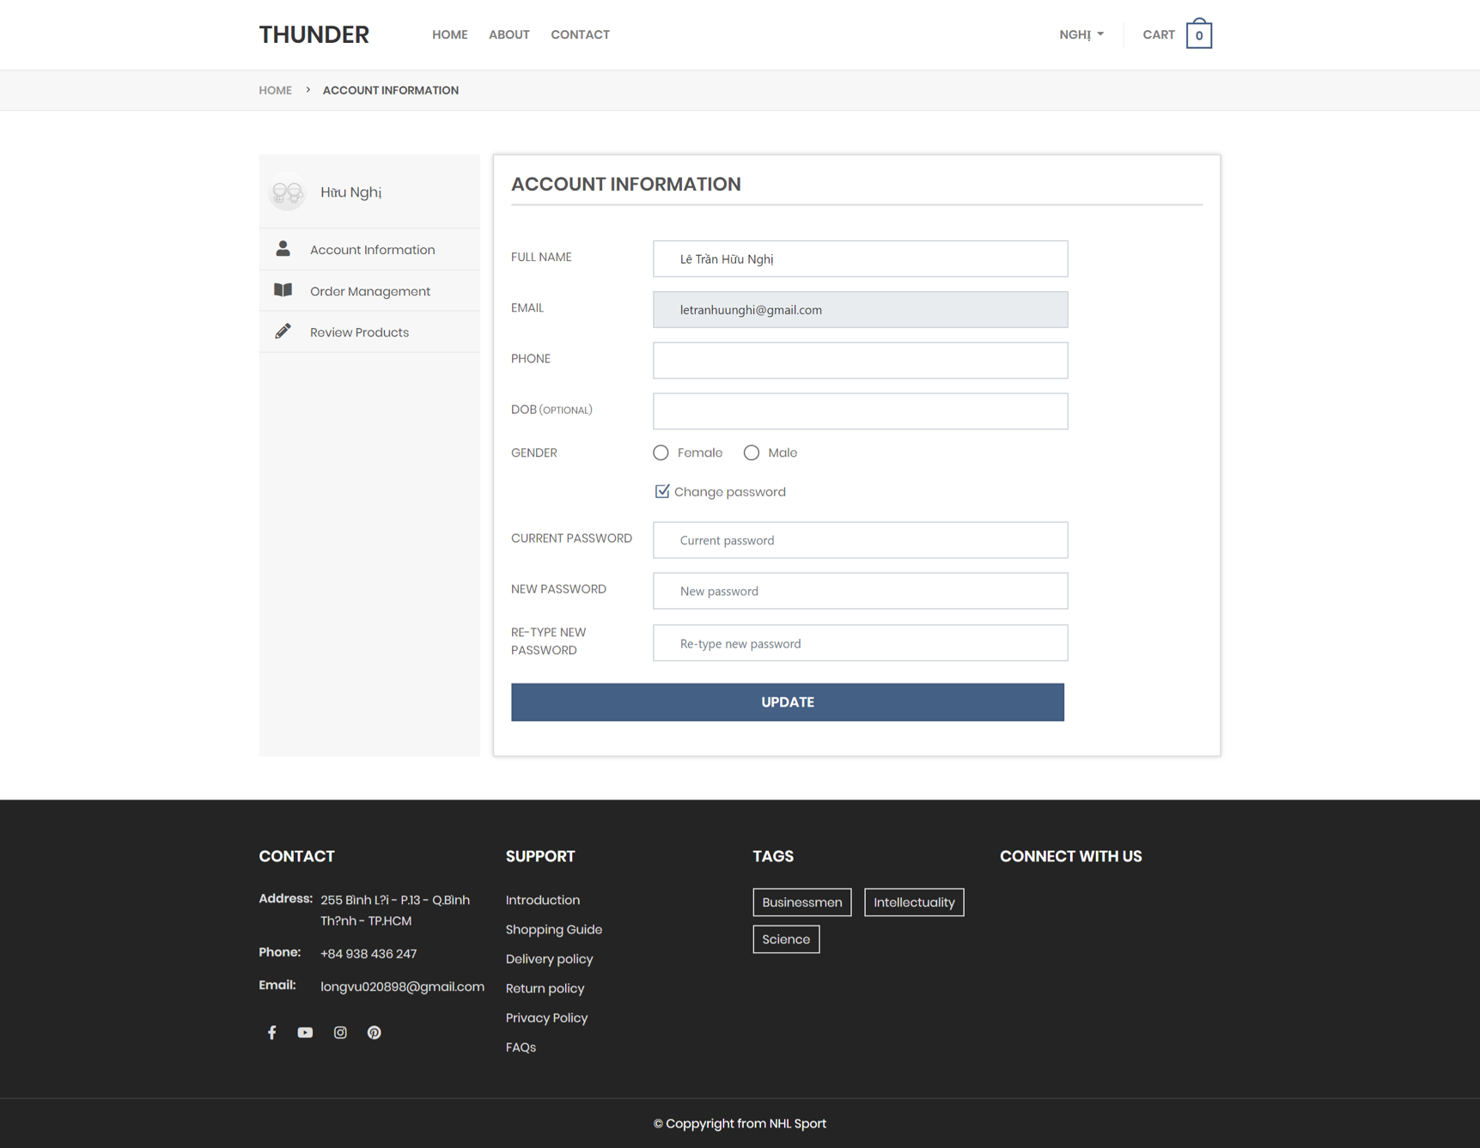If customer want to change password, they can check “Change password”

1. 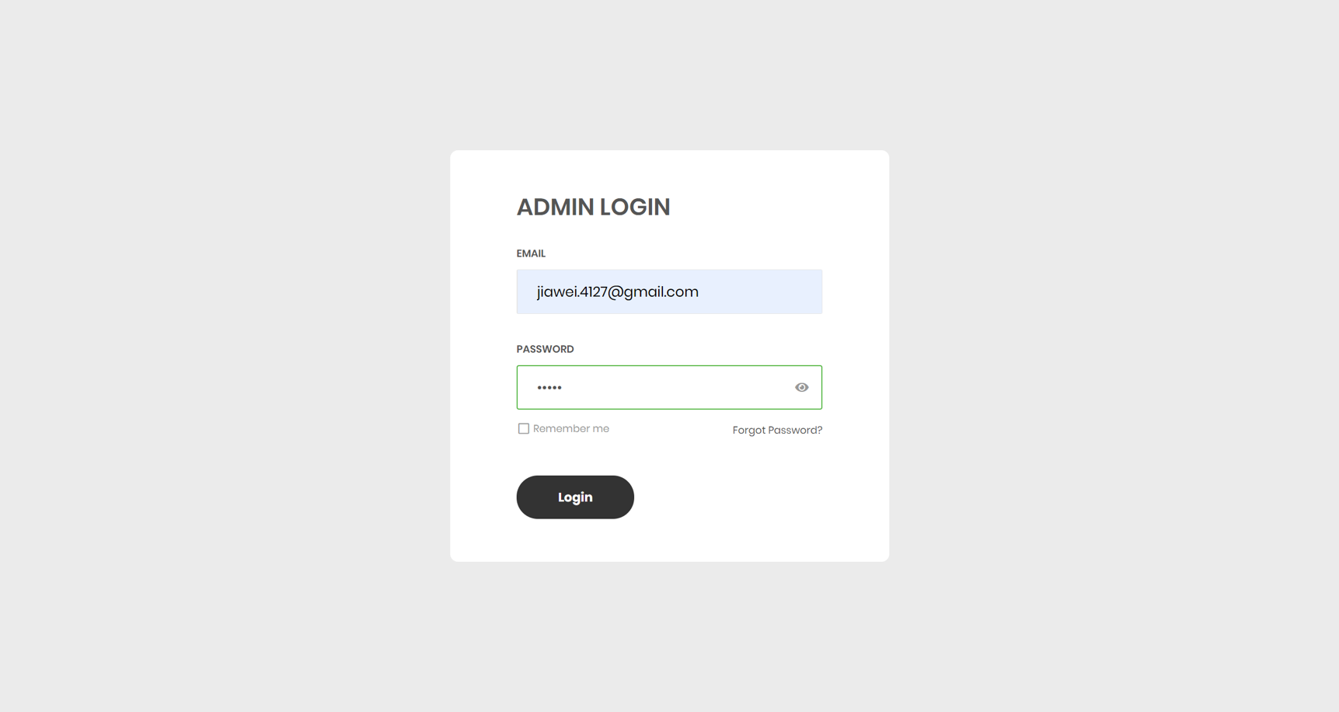**Admin login:**
2. 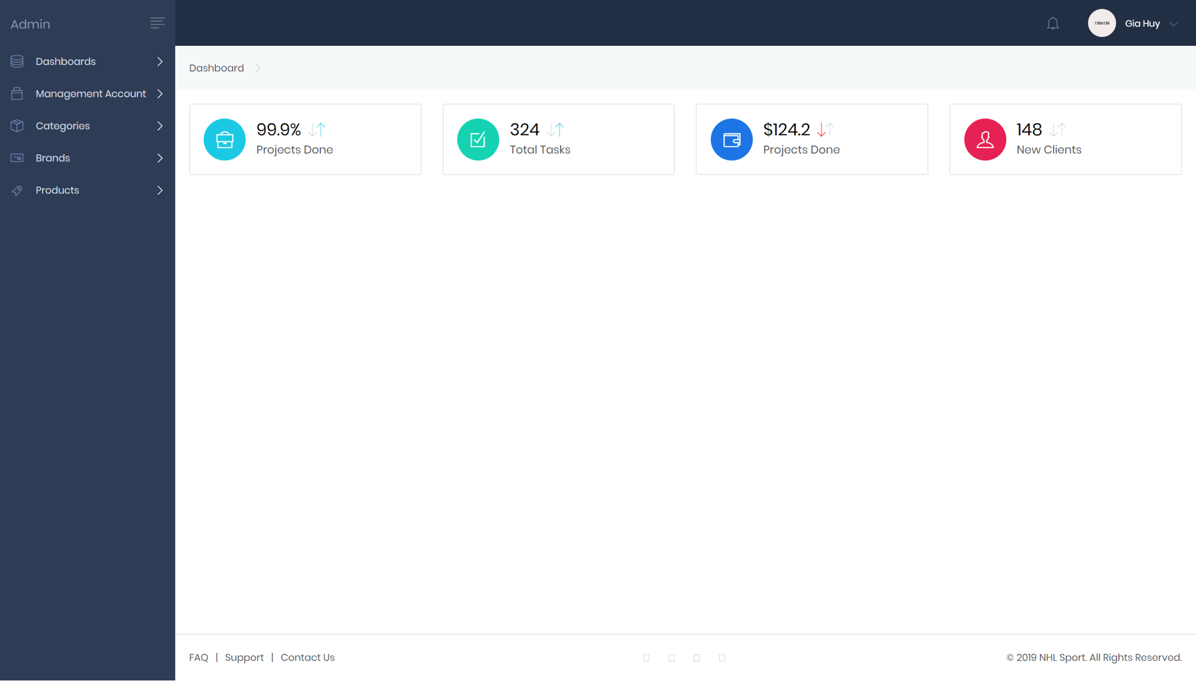**Admin dashboard:**
3. **Employee management for admin:**

Admin can view all information of employees, can add new employee and disable employee. Besides, admin can search employeee

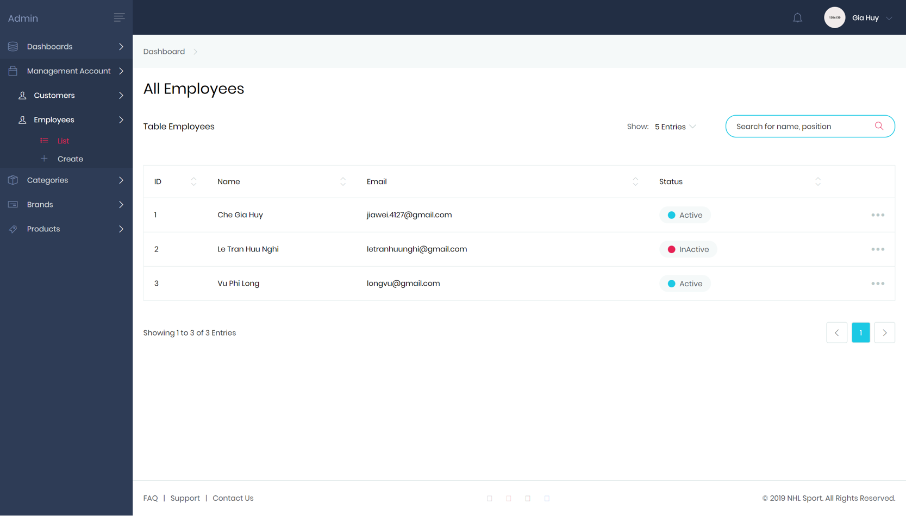

1. **Product management:**

Admin and employee can view all information of product, can add new product, edit product, remove product, set status of product.

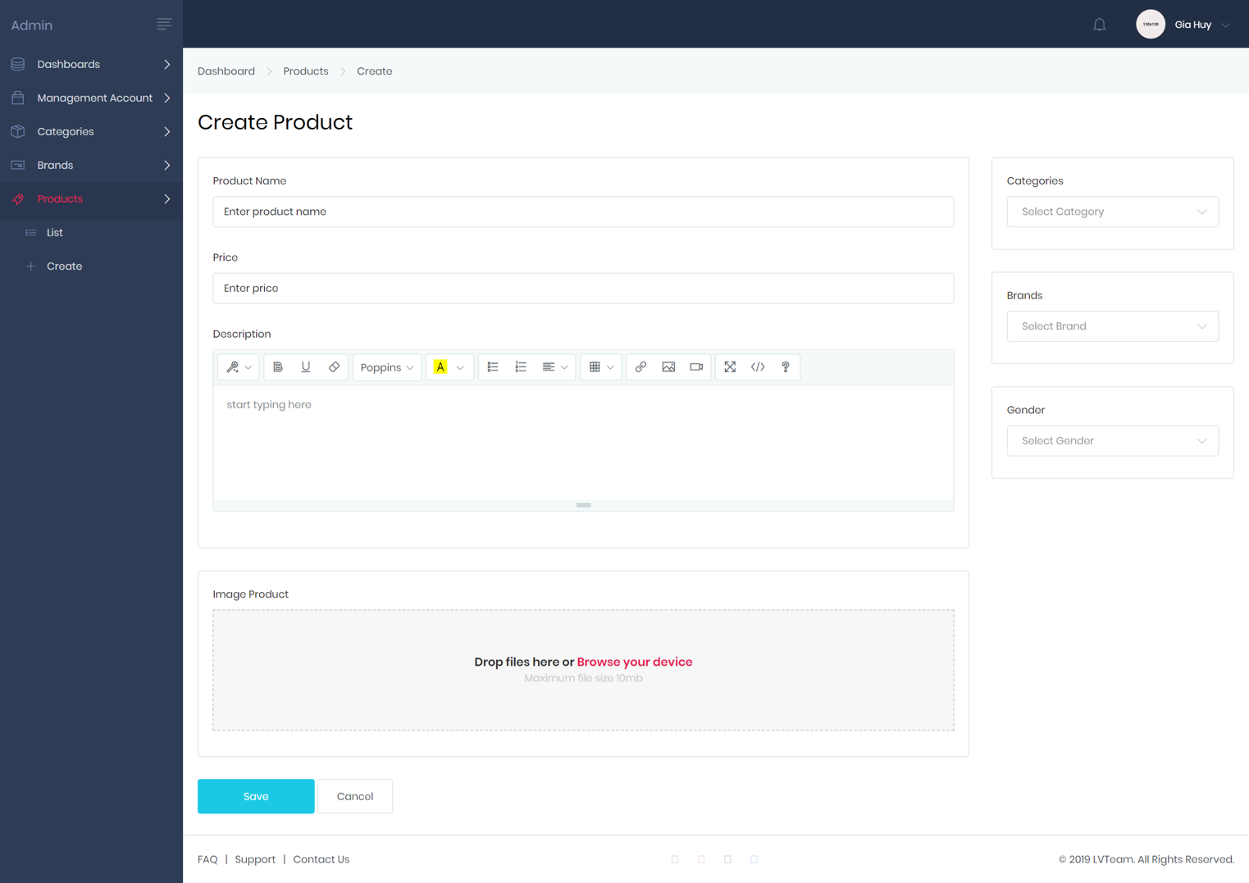

1. **Task Sheet**

|  |  |  |  |  |  |  |  |
| --- | --- | --- | --- | --- | --- | --- | --- |
| **Project Ref. No.:**  **Thunder** | | **Project Title:** | **Activity Plan Prepared By:** | **Date of Preparation of Activity Plan:**  **21/05/2020** | | | |
| **Sr.No.** | **Table** | **Actual Start Date** | **Actual Days** | **Team Mate Names** | **Status** |
|  | Products | Thunder | Lê Trần Hữu Nghị | 21/05/2020 | 5 | Lê Trần Hữu Nghị | OK |
|  | Brands | 21/05/2020 |
|  | Category | 21/05/2020 |
|  | Customer | 21/05/2020 | 5 | Vũ Phi Long | OK |
|  | Wishlish | 21/05/2020 |
|  | Voucher | 21/05/2020 |
|  | Orders | 21/05/2020 | 5 | Chế Gia Huy | OK |
|  | Orders Details | 21/05/2020 |
|  | Admins | 21/05/2020 |
|  | Ratings | 21/05/2020 | 5 | Trần Thanh Thiện | OK |